Requirement Analysis
Technology Stack (Architecture & Stack)
Date | 23 June 2026
Team ID
Project Name | UCAB – Online Cab Booking Application
Maximum Marks | 4 Marks

Technical Architecture:
The deliverable includes the architectural diagram given below along with the information captured in Table-1 and Table-2.
Project: UCAB – Online Cab Booking Application
UCAB is a MERN stack based web application that allows users to book cabs online, drivers to manage ride requests, and administrators to control the overall system through a centralized dashboard.
Reference:
https://github.com/vasanthimunduri/U-Cab
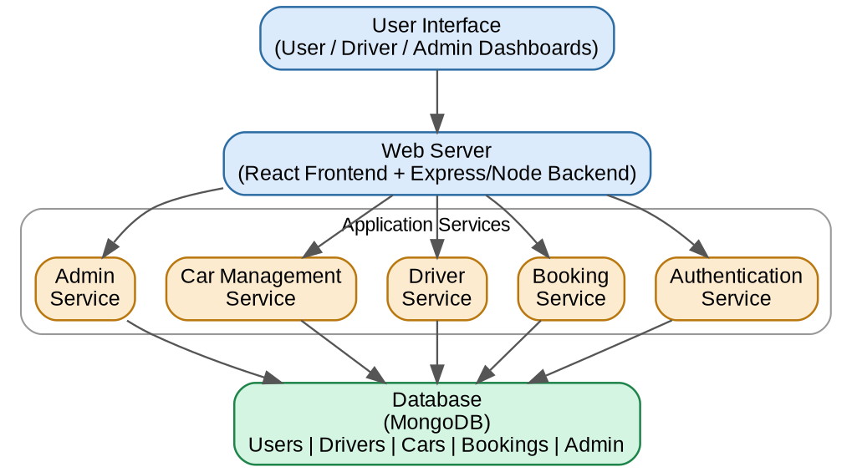

Table-1 : Components & Technologies:
S.No | Component | Description | Technology
1. | User Interface | How the user interacts with the application – Web UI for User, Driver and Admin dashboards. | HTML, CSS, JavaScript, React.js (Vite)
2. | Application Logic-1 | Logic for user registration, login, profile management and cab booking. | Node.js / Express.js
3. | Application Logic-2 | Logic for driver ride management, availability and booking updates. | Node.js / Express.js
4. | Application Logic-3 | Logic for admin control over users, drivers, cars and bookings. | Node.js / Express.js
5. | Database | Stores user, driver, car, booking and admin data. | MongoDB (NoSQL) with Mongoose ODM
6. | Cloud Database | Database service on cloud (optional deployment). | MongoDB Atlas
7. | File Storage | File storage requirements for static assets. | Local Filesystem
8. | External API-1 | Purpose of external API used in the application. | Not Applicable
9. | External API-2 | Purpose of external API used in the application. | Not Applicable
10. | Machine Learning Model | Purpose of Machine Learning Model. | Not Applicable
11. | Infrastructure (Server / Cloud) | Application deployment on local system / cloud. | Local (Node/Express server), Vercel (frontend hosting)

Table-2: Application Characteristics:
S.No | Characteristics | Description | Technology
1. | Open-Source Frameworks | List of the open-source frameworks used. | React.js, Express.js, Node.js, Mongoose
2. | Security Implementations | Security / access controls implemented. | JWT Authentication, bcryptjs password encryption, role-based access control
3. | Scalable Architecture | Justification of the scalability of the architecture. | 3-tier architecture (Presentation – React, Application – Express/Node, Data – MongoDB) following the MVC pattern
4. | Availability | Justification of the availability of the application. | Stateless REST APIs enabling horizontal scaling
5. | Performance | Design considerations for the performance of the application. | Efficient MongoDB queries and indexing, optimized React rendering

References:
https://github.com/vasanthimunduri/U-Cab
https://cab-nine-theta.vercel.app/
https://www.mongodb.com/docs/
https://expressjs.com/
https://react.dev/

